ONE FOR THE LADIES!!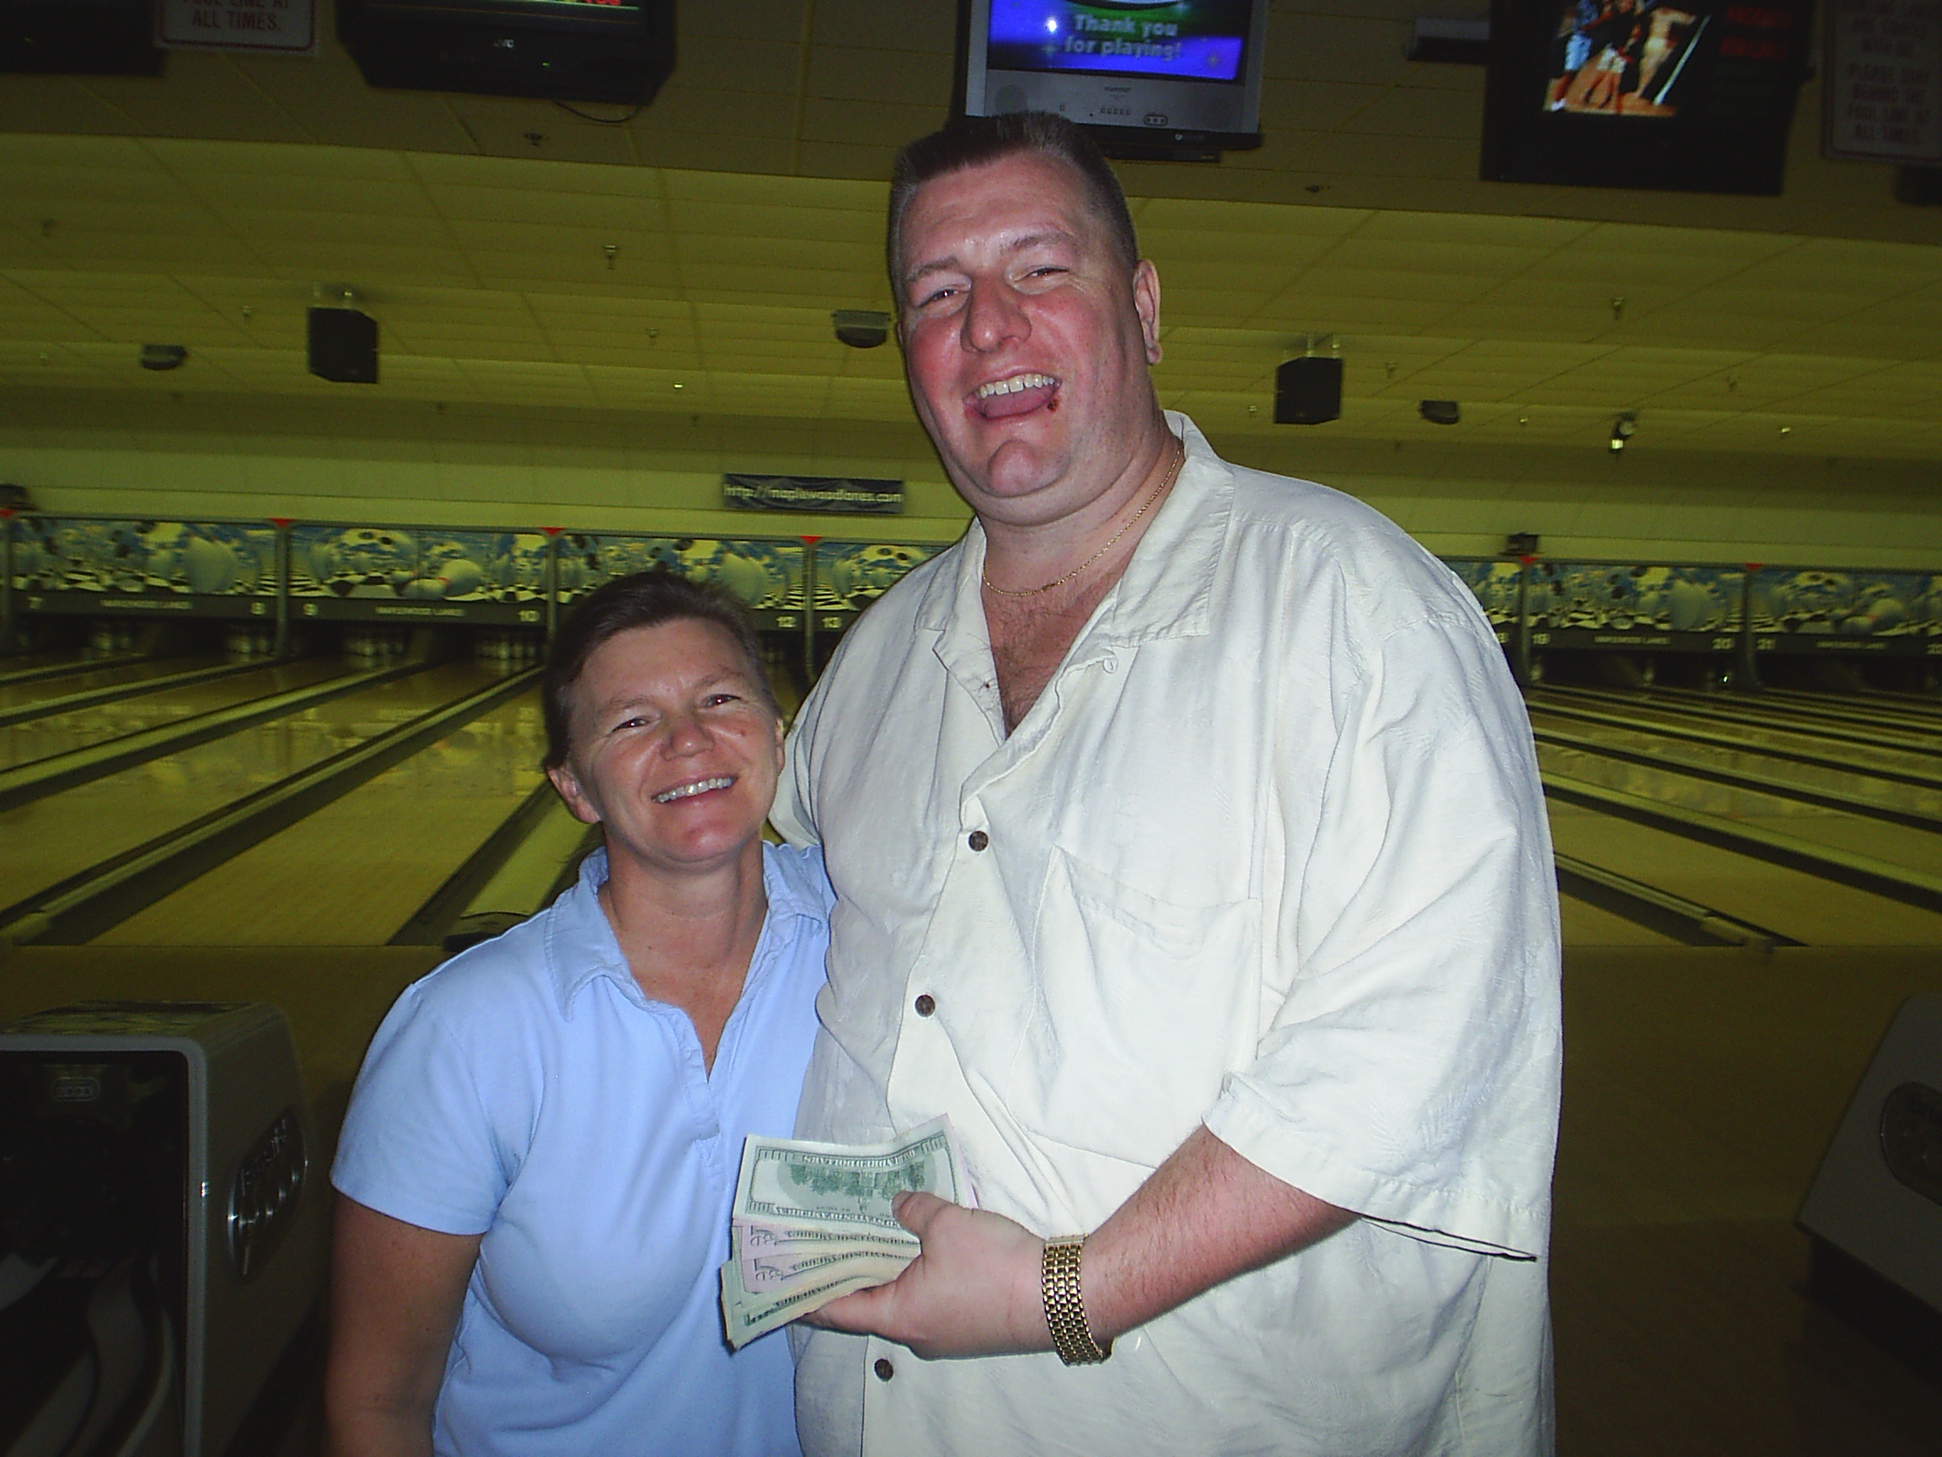

Think you need a big 200+ average to win? Think again!

Congratulations to Karen Wiedmeyer for her 213 - 188 victory over Dean Shipman in the final match of Rondot's Turkey Shoot Sweeper! Karen was enthusiastically cheered on by her husband Rod and the rest of her family as she plowed through the field of 68 bowlers to claim her $450 Thanksgiving bonus. Not bad for a 173 average bowler - not bad at all!! The "cut score" to make the match play round was 686 with handicap. A 170-average bowler would only have to shoot a scratch series of 542 to cover that!

Karen's run for the title was no cakewalk. She got by Patrick Keene-Ashcraft 239-228 (handicap), and then squeaked past Bryan Cody 209-206 to find herself facing the ever tough multiple champion Travis Raskey in the semifinal match. Never so much as blinking once, she didn't need any of her 45 pin handicap as her scratch score was enough to send Travis packing. In her title bout with Dean, things were looking bleak in the middle of the game, but she hung tough (including a clutch conversion of a 3-10 "baby" split in a late frame) to claim the title.

As said before, 68 bowlers competed. Low to cash was 682 with handicap. Chris Harwood led all bowlers with a 773 handicap series across three different lane conditions. Congratulations to everyone!

Top Cashers

1st $450.00 Karen Wiedmeyer
2nd $225.00 Dean Shipman
3-4 $125.00 Travis Raskey, Adam Smith
5-8th $75.00 Bryan Cody, Joe Grambaugh, Chris Harwood,
Rod Radant

9-16th $50.00 Patrick Keen-Ashcraft, Ed Vasas,
Nunzio Marino, Dave Thompson,
Ray Frederick, Chris Holifield,
Chris Collar, Pam McIntire
17th Tie $25.00 Rich Smith, Zac Davis

The bowlers were each given a survey sheet asking for opinions about our tournaments, to be filled out and turned in that night. Almost everyone did, and we thank you. I haven't looked at those yet, but rest assured that I will and the opinions provided will be strongly considered as we tweak the rules and format for the most appeal to a majority. These are your tournaments, folks - the more bowlers we can get, then the more fun and $$$ are available for everyone!
WWW.EdRondotsProShop.com
2008 Shoot Out Series
Super Bowl Shootout!
1. This tournament is certified by and open to all USBC members. The tournament starts at noon February 3, 2008. Entries close at noon, February 3, 2008, or when field is full. Only a prepaid entry will reserve a spot! Host center Maplewood Lanes 830 Woodland Dr. Saline, MI 48176 Ph. 734-429-5457.
- The tournament is handicapped 80% from 230. Bowlers will use last year’s (2006-2007) highest average of 21 or more games. If no average last year, the highest average of 21 games from 2005-2006 will be accepted. If the bowler has no yearbook average from either year, a current season, 2007 or 2006 summer league average of 21 games or more (in that order) as of the tournament date will be accepted. Bowlers that cannot provide any of these averages must bowl scratch.
2a. If current season average for at least 21 games at the time of bowling exceeds last season’s average by 10 or more pins, current season average will be used (rule 319a, item 2).
2b. Reporting of previous tournament prize winnings will not apply (rule 319d). The average adjustment rule will not apply (rule 319e).
2c. Failure to report a correct average can result in disqualification or lower prize winnings. (Rule 319a item 3).
- Bowlers will bowl three games across 6 lanes in qualifying. The top 16 handicapped qualifying scores will advance to match play. If the field exceeds 92 entries the top 24 bowlers with handicap will advance to match play with the top eight receiving a bye out of the first round. If the field is smaller than 24 the matchplay field will be cut to 12 finalists with the top four qualifiers receiving a bye out of the first round. Matchplay will consist of one game handicapped head to head matches. The first round pairings will be determined by random draw. Subsequent matches will follow a standard 16-person bracket. The winners of each round will advance to the next round of matches until there is one player left undefeated. That player will be declared the champion
- In the case of a tie for the last matchplay spot(s) after the three game qualifying round a one game handicap roll off will be conducted to fill the final positions. In case of a tie during one of the matchplay rounds other than the championship round a ninth and tenth frame roll off will be held, each bowler will receive 1/5 of their individual game handicap added to their pinfall to determine the winner. A one game roll off with handicap will break a tie at the completion of the championship match.
- Entry fees are $40.00. Lineage $10.00, Tournament expenses $6.00, Prize fees $24.00. All prize fees will be returned 100%.
- The Prize Ratio shall be no less than 1:4. Estimated Prize list (based on 50 entries) 1st-$250.00, 2nd-150.00, 3&4th-100.00, 5-8th-$70.00, and 9-16th $40.00.
- USBC playing rules shall govern situations not addressed in these rules. All decisions of the tournament manager are final unless an appeal is made in accordance with USBC Rule329.
Entry Form

Name: _____________________ Telephone: ___________________

Address________________________________ City__________________________ ZIP_________ Email Address:______________________________________

Highest 2006-2007 Yearbook Average: ______________ USBC # __________________________

If none, Highest 2005-2006 Yearbook Average (any Assn.): _________________

