Equipment Review: 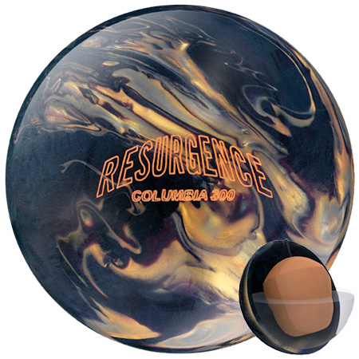
Columbia 300 Resurgence

Skepticism has grown exponentially over Columbia 300’s recent history of high performance ball releases. The reborn company needed a home run to win back their fans. The Resurgence is a Grand Slam!

Technical Skinny:

I drilled the Resurgence 4-1/2 x 4 with the pin below the fingers, weight hole (1inch diameter) two inches below PAP (4-5/8 right, ¼ down).

Initial tests forced me to be very soft at the release point to store energy far enough down the lane. Any aggressive releases resulted in weak hits on all but the heaviest and longest oil patterns.

First solution: Apply polish (Brunswick Ruff Buff)
Result: Hydroplane, Speed Sensitivity

Modification: Cut polish lightly with an old green Scotch Brite Pad.
Result: Area and CARRY!

The combination of surface adjustments allowed me to identify the oil line continuously through my league sessions. The medium differential provided enough pop off the dry to use the track for recovery and yet track well enough to prevent hydroplaning on a tug into the inside oil. Basically the ball allowed me to see more of a blend when many people were experiencing wet/dry.

My experiences have led me to believe that if a ball company develops an outstanding coverstock then their products will excel. That may sound over-simplified but look back in history or ask any manufacturer. Columbia’s New Era Reactive coverstock is a winner! I am confident that The Resurgence is just the beginning of many outstanding releases by Columbia.

